|  |  |
| --- | --- |
| **Composition:** | Each uncoated tablet contains :  Ursodeoxycholic Acid IP: 150 mg |
| **Product Code No.:** | F01 |
| **Shelf Life:** | 2 years |
| **Ref. MFR No.:** | TABMFR019/03 |
| **Format No.:** | TABBPR019/03 |
| **Superseded Document No.:** | TABBPR019/02 |

|  |  |  |  |
| --- | --- | --- | --- |
|  | **Name** | **Designation** | **Sign/date** |
| **Prepared by:** |  |  |  |
| **Checked by:** |  |  |  |
|  |  |  |
|  |  |  |
|  |  |  |
| **Reviewed by:** |  |  |  |
| **QA Approval:** |  |  |  |

|  |  |
| --- | --- |
| **Effective Date:** | **Review Date: Jul-2026** |

|  |  |  |  |
| --- | --- | --- | --- |
| **Batch Commences On** |  | **Batch Finishes On** |  |

**General Instructions**

1. The BPR should be issued & endorsed by QA.
2. The BPR should be checked by QA during Batch Release and archived by QA along with other relevant documents.
3. Always follow the latest version of the SOPs issued by QA.
4. Record any observed Deviation from the MFR and inform the QA for further investigations.

**STAGE 1A: DISPENSING**

**Instructions:**

1.1 Dispense the materials under dispensing booth at the Material Store and get counter checked by the production / QA personnel.

1.2 Dispense all the ingredients in polythene sacks/suitable containers.

1.3 Tie the tags or write on the sacks with a marker pen all the relevant information about the raw material.

1.4 Weigh/ Measure all the excipients before weighing of active ingredients.

1.5 Weigh / Measure all the ingredients as per the Production Order issued by the Production Dept.

1.6 The Quantity of the API, Ursodeoxycholic Acid IP is to be calculated on 100% Assay basis

by QA and it is to be noted on the Production Order and duly signed by the QA personnel. The difference in weight is to be adjusted with M.C.C (Avicel PH 101)

**STAGE 1B: COUNTER-CHECKING AT PRODUCTION**

**Instructions:**

* 1. Transfer the materials kept at the R.M. Hold Area to the Charge Area.
  2. Counter-check the dispensed quantity of all the items.

**DISPENSING RECORD**  P.O No.: DATE:



**Calculated Qty: Ursodeoxycholic Acid - Avicel PH 101 -**

*On 100% Assay basis

**Manufacturing Process Flow Chart**

**BINDER PREPARATION**

**CHARGING/ MIXING**

**MILLING / SIFTING**

**DRYING**

**QC ANALYSIS - FINISHED PACK**

**QC ANALYSIS -**

**PRE-PACKING**

**MILLING / SIFTING**

**STRIP PACKING**

**COMPRESSION**

**LUBRICATION**

**DELIVERY TO FINISHED STORE**

**SECONDARY PACKING**

**STAGE 2: SIFTING**



**Instructions:**

2.1 Counter check the weights of all ingredients before using in the batch.

2.2 Transfer requisite quantities of Item Nos. 1-4 to the Sifting area.

2.4 Sift the materials by a Vibratory Sifter fitted with 30# mesh.

2.5 Note down the size and no. used, as well as the integrity of the sieve before and after pulverizing / sifting of the materials.

2.6 Record the observations in Table.

Temperature °C & Humidity % RH.

**Table: Sifting Details**



**STAGE 3: DRY MIXING**



Instructions:

3.1 Load the sifted materials into the planetary mixer and mix at high speed mode for 15 mins.

3.2 Record the observation in table.

Temperature °C & RH %.

**Table: Dry Mixing Detail**

**STAGE 4: BINDER PREPARATION**



**Instructions:**

* 1. In a clean dry 45 lts. S. S. Vessel, take Isopropyl alcohol add P.V.P.-K30 and stir for 30 minutes or until the solution is clear. (Solution-1)
  2. In another clean dry 2 Lts S.S Mug take Methylene Chloride, add P.E.G.-6000 and stir for 15 mins. (Solution-2)
  3. Cover the S. S. vessels with lids & affix the tags Solution-1 & Solution-2 respectively.

**Table: Binder Preparation Details**



**STAGE 5: WET MIXING**

**Instructions:**

5.1 Add the Solutions 2 & 1 respectively to the dry mix blend of Stage 3 in the PLM and mix properly to get good lumps & granules.



**STAGE 6: DRYING**



**Instructions:**

6.1 Load the wet mass in the S.S. trays of the Tray drier homogenously

6.2 Air-dry the mass for 8 to 10 hrs.

6.3 Dry further 30 to 45 minutes at 45°C if required.

**Table: Drying Operation**



6.4 Unload the dried mass from drier and collect in clean plastic drum with a fresh polythene sack placed inside.



**STAGE: 7 SIZE REDUCTION**



**Instructions:**

7.1 Transfer the material from stage 6 to the milling area.

7.2 Mill the material using an Oscillating Granulator through 12# sieve.

7.3 Collect the granules in polythene sacks placed in PVC containers & record the weight.

Temperature °C & Humidity % RH

**Table: Sizing Details**

|  |  |  |  |  |  |  |  |  |  |  |
| --- | --- | --- | --- | --- | --- | --- | --- | --- | --- | --- |
| Stage | Date | Time | Qty. Milled in Kgs | | | Sieve Size in mm /# as per m/c | Sieve Integrity | | Done By | Checked By |
| Gross Wt. | Tare Wt. | Net Wt. | Before | After |
| 7.2 |  |  |  |  |  |  |  |  |  |  |
|
|

Total Wt. of Dried granules: Kg Checked by & date:

**STAGE: 8 LUBRICANT SIFTING**



**Instructions:**

8.1 Counter check the weights of all ingredients before using in the batch.

8.2 Sift SSG, Talc, Magnesium Stearate and Aerosil-200 through 60# sieve.

8.3Record the sieve size used, as well as the integrity of the sieve before and after sifting of individual material.

8.4 Check for the residue if any from each material for appearance and quantity.

8.5 Record the observations in table.

Temperature °C & Humidity % RH

**Table: Sifting Details**

|  |  |  |  |  |  |  |  |  |
| --- | --- | --- | --- | --- | --- | --- | --- | --- |
| Date: | | | Time From: | | | Time To: | | |
| Sl. | Ingredients | Qty in Kgs (Net) | Wt. Chkd by | Sieve Size & No. | Sieve Integrity Test | | Done by | Chkd by |
| Before | After |
| 1 | Sodium Starch Glycollate | 0.800 |  |  |  |  |  |  |
| 2 | Aerosil-200 | 0.160 |
| 3 | Talc | 0.500 |
| 4 | Magnesium stearate | 0.160 |

**STAGE: 9 LUBRICATION**



**Instructions:**

9.1Transfer the sized granules from stage 8 to the mixing area.

9.2 Load the dried sifted granules into the planetary mixer.

9.3 Add Sodium Starch Glycolate & Aerosil 200 and mix for 6 mins at slow speed mode.

9.4 Add Talcum & Magnesium stearate and mix for 3 mins at slow speed.

Temperature °C & RH %

**Table: Lubrication details**



**STAGE 10: Weighing Record of Lubricated Granules**

10.1 Unload the final mixed granules in double polythene lined tightly closed container.

10.2 Record the observations in table.

|  |  |  |  |  |  |
| --- | --- | --- | --- | --- | --- |
| Drum No. | Gross Weight (Kg) | Tare Weight (Kg) | Net Weight (Kg) | Done By | Checked By & Date |
| 1 |  |  |  |  |  |
| Total | | |  |  |  |

**Calculation of Yield:**

Theoretical Yield:

Actual Yield:

Difference: % Yield:

**STAGE: 11 TABLET COMPRESSION**



**Instructions:**

11.1 Transfer the blended materials to the compression room.

11.2 Set & operate the compression machine as in following table.

11.3 Carry out initial checking as in following table.

11.4 Carry out the following in-process controls as per the given frequency & Record.

11.4.1 Weight of 10 tablets (5 from each station) every 30 mins.

11.4.2 Thickness of 10 tablets (5 from each station) every 2 hours

11.4.3 Hardness of 6 tablets (3 from each station) every 2 hours.

11.4.4 Appearance of one round of tablets every 2 hour.

11.4.5 Disintegration time of 12 tablets (6 from each station) every 4 hour.

11.4.6 Friability of 33 tablets once in a day.

11.4.7 Wt. variation test as per IP on 20 tablets every 4 hour.

11.4.8 Check for spots on tablets from lubrication oil every 30 mins.

11.4.9 Collect the tablets in double polythene sack lined containers.

11.4.10 Compress tablet with 33 stn Rotary Compression m/c with flat circular punch.

11.4.11 Record the weight of compressed tablets in table

**Punch Details**: 7.95 mm dia, BB tooling, flat, circular, bevelled edged **Tool Code:** TT12

**Upper punch:** B/L **Lower punch: Plain**

**Table: Compression Specifications**

|  |  |  |  |  |  |
| --- | --- | --- | --- | --- | --- |
| **Tablet parameter** | **Specification set at** | | **Tablet parameter** | | **Specification set at** |
| Av. Tablet Weight | mg | | Limits for individual Tablets (±5%) | | mg |
| Weight of 10 Tabs | gm | | Thickness range in mm | | 3.45-3.70 mm |
| Hardness in kg | | 5-10 kgf | | Disintegration Time | NMT 15 mins |
| Friability | | NMT 1% | | Weight Variation | NMT 7.5% |

**Initial Checking [Machine Setting]**

|  |
| --- |
| Appearance of initial 33 tablets, one from each punch & compression point |
| Standard: White Circular flat bevelled edged tablets with bisecting mark on one side. |
| Observed: |
| Checked By: Date: |

|  |  |  |  |  |  |  |  |
| --- | --- | --- | --- | --- | --- | --- | --- |
| Parameter | Std. Limits | Observations | | | | | Checked By & Date |
| Wt of 20 tablets (mg) |  |  |  |  |  |  |  |
|  |  |  |  |  |
|  |  |  |  |  |
|  |  |  |  |  |
| Average Weight (mg) |  |  | | | | |  |
| Weight Variation | NMT 7.5% |  | | | | |  |
| Thickness of 10 tablets (mm) | 3.45-3.70 |  |  |  |  |  |  |
|  |  |  |  |  |
| Hardness of 5 tablets (kgf) | 5-10 |  |  |  |  |  |  |
| Disintegration time (min. Sec) | 15 min |  | | | | |  |
| Friability (%) | NMT 1% |  | | | | |  |

First two/ three rounds of tablets should be discarded when the m/c is set up for the production after change over cleaning.

M/C Adjustment Rejection: Kg

Date :

Checked By (Prod):

**IN- PROCESS RECORD**

|  |
| --- |
| Machine ID: TM-MC-TC- |
| Record the data as per specified frequency |

|  |  |  |  |  |  |  |  |  |  |  |
| --- | --- | --- | --- | --- | --- | --- | --- | --- | --- | --- |
| **Date** | **Time** | **Appearance** | **Wt. of 10 tabs (gm)** | **Hardness (kgf)** | **DT (Min. Sec)** | **Thickness (mm)** | **Friability (33 tabs)** | **Oil Spot** | **Operator T.No.** | **Checked By (Pdn. / QA)** |
|  |  |  |  |  |  |  |  |  |  |  |
|  |  |  |  |  |  |  |  |  |  |  |
|  |  |  |  |  |  |  |  |  |  |  |
|  |  |  |  |  |  |  |  |  |  |  |
|  |  |  |  |  |  |  |  |  |  |  |
|  |  |  |  |  |  |  |  |  |  |  |
|  |  |  |  |  |  |  |  |  |  |  |
|  |  |  |  |  |  |  |  |  |  |  |
|  |  |  |  |  |  |  |  |  |  |  |
|  |  |  |  |  |  |  |  |  |  |  |
|  |  |  |  |  |  |  |  |  |  |  |
|  |  |  |  |  |  |  |  |  |  |  |
|  |  |  |  |  |  |  |  |  |  |  |
|  |  |  |  |  |  |  |  |  |  |  |
|  |  |  |  |  |  |  |  |  |  |  |
|  |  |  |  |  |  |  |  |  |  |  |
|  |  |  |  |  |  |  |  |  |  |  |

**Attach additional sheet if required, to be endorsed by QA**

**IN- PROCESS RECORD**

|  |
| --- |
| Machine ID: TM-MC-TC- |
| Record the data as per specified frequency |

|  |  |  |  |  |  |  |  |  |  |  |
| --- | --- | --- | --- | --- | --- | --- | --- | --- | --- | --- |
| **Date** | **Time** | **Appearance** | **Wt. of 10 tabs (gm)** | **Hardness (kgf)** | **DT (Min. Sec)** | **Thickness (mm)** | **Friability (33 tabs)** | **Oil Spot** | **Operator T.No.** | **Checked By (Pdn. / QA)** |
|  |  |  |  |  |  |  |  |  |  |  |
|  |  |  |  |  |  |  |  |  |  |  |
|  |  |  |  |  |  |  |  |  |  |  |
|  |  |  |  |  |  |  |  |  |  |  |
|  |  |  |  |  |  |  |  |  |  |  |
|  |  |  |  |  |  |  |  |  |  |  |
|  |  |  |  |  |  |  |  |  |  |  |
|  |  |  |  |  |  |  |  |  |  |  |
|  |  |  |  |  |  |  |  |  |  |  |
|  |  |  |  |  |  |  |  |  |  |  |
|  |  |  |  |  |  |  |  |  |  |  |
|  |  |  |  |  |  |  |  |  |  |  |
|  |  |  |  |  |  |  |  |  |  |  |
|  |  |  |  |  |  |  |  |  |  |  |
|  |  |  |  |  |  |  |  |  |  |  |
|  |  |  |  |  |  |  |  |  |  |  |
|  |  |  |  |  |  |  |  |  |  |  |

**Attach additional sheet if required, to be endorsed by QA**

**In-Process Check by QA**

Date: Time: M/c ID: TM-MC-TC-

Room Temp: RH:

|  |  |  |  |
| --- | --- | --- | --- |
| Description: | | | |
| Thickness (mm) |  | Hardness (Kgf) |  |
| DT |  | Appearance* |  |

* Also check that there are no spots of lubricant oil on the tablets.

**Test for friability:**

|  |  |  |  |
| --- | --- | --- | --- |
| No. of tabs taken | Initial Weight in mg | Final Weight in mg | % Weight Loss |
|  |  |  |  |
| Remarks |  | | |

**Test for Weight Variation**

**% Mean Deviation limits: ±7.5**

|  |  |  |  |  |  |  |  |  |  |
| --- | --- | --- | --- | --- | --- | --- | --- | --- | --- |
| Individual weights of tablets in mg | | | | | | | | | |
|  |  |  |  |  |  |  |  |  |  |
|  |  |  |  |  |  |  |  |  |  |
| Avg |  | Max |  | %Dev |  | Min |  | %Dev |  |
| Remarks |  | | | | | | | | |

Certified that the compressed tablets are confirming to the standards mentioned in the BMR.

___________________________

Signature of QA personnel

**Weight Variation Test:**

**% Mean Deviation limits: ±7.5**

|  |  |  |  |  |  |  |  |  |  |
| --- | --- | --- | --- | --- | --- | --- | --- | --- | --- |
| Date |  | Individual weights of tablets in mg | | | | | | Time |  |
|  |  |  |  |  |  |  |  |  |  |
|  |  |  |  |  |  |  |  |  |  |
| Avg |  | Max |  | %Dev |  | Min |  | %Dev |  |
| Remarks |  | | | | | | | Done by |  |

|  |  |  |  |  |  |  |  |  |  |
| --- | --- | --- | --- | --- | --- | --- | --- | --- | --- |
| Date |  | Individual weights of tablets in mg | | | | | | Time |  |
|  |  |  |  |  |  |  |  |  |  |
|  |  |  |  |  |  |  |  |  |  |
| Avg |  | Max |  | %Dev |  | Min |  | %Dev |  |
| Remarks |  | | | | | | | Done by |  |

|  |  |  |  |  |  |  |  |  |  |
| --- | --- | --- | --- | --- | --- | --- | --- | --- | --- |
| Date |  | Individual weights of tablets in mg | | | | | | Time |  |
|  |  |  |  |  |  |  |  |  |  |
|  |  |  |  |  |  |  |  |  |  |
| Avg |  | Max |  | %Dev |  | Min |  | %Dev |  |
| Remarks |  | | | | | | | Done by |  |

|  |  |  |  |  |  |  |  |  |  |
| --- | --- | --- | --- | --- | --- | --- | --- | --- | --- |
| Date |  | Individual weights of tablets in mg | | | | | | Time |  |
|  |  |  |  |  |  |  |  |  |  |
|  |  |  |  |  |  |  |  |  |  |
| Avg |  | Max |  | %Dev |  | Min |  | %Dev |  |
| Remarks |  | | | | | | | Done by |  |

|  |  |  |  |  |  |  |  |  |  |
| --- | --- | --- | --- | --- | --- | --- | --- | --- | --- |
| Date |  | Individual weights of tablets in mg | | | | | | Time |  |
|  |  |  |  |  |  |  |  |  |  |
|  |  |  |  |  |  |  |  |  |  |
| Avg |  | Max |  | %Dev |  | Min |  | %Dev |  |
| Remarks |  | | | | | | | Done by |  |

|  |  |  |  |  |  |  |  |  |  |
| --- | --- | --- | --- | --- | --- | --- | --- | --- | --- |
| Date |  | Individual weights of tablets in mg | | | | | | Time |  |
|  |  |  |  |  |  |  |  |  |  |
|  |  |  |  |  |  |  |  |  |  |
| Avg |  | Max |  | %Dev |  | Min |  | %Dev |  |
| Remarks |  | | | | | | | Done by |  |

**N.B. Enclose additional sheets if required, to be endorsed by QA.**

**Weight Variation Test:**

**% Mean Deviation limits: ±7.5**

|  |  |  |  |  |  |  |  |  |  |
| --- | --- | --- | --- | --- | --- | --- | --- | --- | --- |
| Date |  | Individual weights of tablets in mg | | | | | | Time |  |
|  |  |  |  |  |  |  |  |  |  |
|  |  |  |  |  |  |  |  |  |  |
| Avg |  | Max |  | %Dev |  | Min |  | %Dev |  |
| Remarks |  | | | | | | | Done by |  |

|  |  |  |  |  |  |  |  |  |  |
| --- | --- | --- | --- | --- | --- | --- | --- | --- | --- |
| Date |  | Individual weights of tablets in mg | | | | | | Time |  |
|  |  |  |  |  |  |  |  |  |  |
|  |  |  |  |  |  |  |  |  |  |
| Avg |  | Max |  | %Dev |  | Min |  | %Dev |  |
| Remarks |  | | | | | | | Done by |  |

|  |  |  |  |  |  |  |  |  |  |
| --- | --- | --- | --- | --- | --- | --- | --- | --- | --- |
| Date |  | Individual weights of tablets in mg | | | | | | Time |  |
|  |  |  |  |  |  |  |  |  |  |
|  |  |  |  |  |  |  |  |  |  |
| Avg |  | Max |  | %Dev |  | Min |  | %Dev |  |
| Remarks |  | | | | | | | Done by |  |

|  |  |  |  |  |  |  |  |  |  |
| --- | --- | --- | --- | --- | --- | --- | --- | --- | --- |
| Date |  | Individual weights of tablets in mg | | | | | | Time |  |
|  |  |  |  |  |  |  |  |  |  |
|  |  |  |  |  |  |  |  |  |  |
| Avg |  | Max |  | %Dev |  | Min |  | %Dev |  |
| Remarks |  | | | | | | | Done by |  |

|  |  |  |  |  |  |  |  |  |  |
| --- | --- | --- | --- | --- | --- | --- | --- | --- | --- |
| Date |  | Individual weights of tablets in mg | | | | | | Time |  |
|  |  |  |  |  |  |  |  |  |  |
|  |  |  |  |  |  |  |  |  |  |
| Avg |  | Max |  | %Dev |  | Min |  | %Dev |  |
| Remarks |  | | | | | | | Done by |  |

**N.B. Enclose additional sheets if required, to be endorsed by QA.**

**Weighing Record of Compressed Tablets:**



|  |  |
| --- | --- |
| **Total Weight of Tablets Manufactured** | **Equivalent Quantity in Nos.** |
|  |  |



**% Yield = (Total No. of tablets manufactured/ Batch Size) X 100 = %**

Calculated By & Date___________________ Checked By & Date_______________________

After receiving the Analysis Report from QC transfer the compressed tablets to the Tablet Strip Section.

**Analysis Report – Pre-Packing:** Q.C. No. : Date:

Issued By____________________ Received By__________________ Date____________

**Hold Time: NMT 14 days for compressed tablets. Raise a Deviation Note if Packing is delayed.**

**P A C K A G I N G R E C O R D S**

|

**STAGE -1 (ISSUANCE OF PACKING MATERIALS)**

A. SALES PACK QTY: TABS



B. SAMPLE PACK QTY: TABS

*For specimen to be enclosed in BPR & for QC Sample

**P A C K A G I N G R E C O R D S**

**Standard Pack Format:**

|  |
| --- |
| **Sales Pack:** **10 tabs packed in Alu-foil. 10 Strips in each Carton. 20 Cartons packed in each Shipper Box.**  **P.S. Pack:** 2 **tabs packed in Alu-foil. 50 Strips + 50 nos. PS Box in each Shipper Box.** |

**STAGE – 2 (STRIP PACKING)**

**Instructions:**

1. Transfer the approved Tablet containers into strip packing area, check proper labeling, tablet etc.
2. Transfer the printed Alu. Foil and Plain Alu. Foil to the Strip packing area
3. Set the pre-printed rubber stereos and check the printing matter along with printing quality.
4. Take over- printed foil as a proof copy and sign it with date and also get it counter checked by QA.
5. Check the room temperature and relative humidity before starting the strip packing and record it.
6. Maintain the Sealing roller(s) temperatures during the operation.
7. Carry out the Strip Integrity Test when machine starts and after every shutdown/ adjustment.



**Table: Manufacturing Record**



**No. of Batch Stereo in Printing Roller: Total: Nos.**

**P A C K A G I N G R E C O R D S**

**Standard Pack Format:**

|  |
| --- |
| **Sales Pack:** **10 tabs packed in Alu-foil. 10 Strips in each Carton. 20 Cartons packed in each Shipper Box.**  **P.S. Pack:** 2 **tabs packed in Alu-foil. 50 Strips + 50 nos. PS Box in each Shipper Box.** |

**STAGE – 2 (STRIP PACKING)**



**Table: Manufacturing Record**



**No. of Batch Stereo in Printing Roller: Total: Nos.**

**Foil Cutting Length: 4 Pockets.**

|  |  |
| --- | --- |
| Type Of Pack | Standard Quantity Of Tablets/Strip |
| Alu-Alu Foil Pack | 10 Tablets(Sales) / 2 Tablets(P.S) |

**P A C K A G I N G R E C O R D S**

**Strip Integrity Test**

(Frequency: M/C starting time & after every shutdown / adjustment)

Name of instrument: Leak Testing Apparatus Instrument No: CP-IN-LTA-

Ref. SOP No. DMSGEN103

|  |  |  |  |  |  |  |  |
| --- | --- | --- | --- | --- | --- | --- | --- |
| Date | Time | No. of Strip | No of Tablets | Result | No of pocket leakage | Chkd. by Prod/QA | Remarks |
|  |  |  |  |  |  |  |  |
|  |  |  |  |  |  |  |  |
|  |  |  |  |  |  |  |  |
|  |  |  |  |  |  |  |  |
|  |  |  |  |  |  |  |  |

**In-process check during Primary (Blister) Packing (Frequency: every 2 hours)** 

* Defects: 1. Misprint. 2. Cut on the foil. 3. Empty Pockets. 4. Improper Seal 5. Any Other-Specify.

**N.B. Enclose additional sheets if required, to be endorsed by QA.**

**P A C K A G I N G R E C O R D S**

**Strip Integrity Test**

(Frequency: M/C starting time & after every shutdown / adjustment)

Name of instrument: Leak Testing Apparatus Instrument No: CP-IN-LTA-

Ref. SOP No. DMSGEN103

|  |  |  |  |  |  |  |  |
| --- | --- | --- | --- | --- | --- | --- | --- |
| Date | Time | No. of Strip | No of Tablets | Result | No of pocket leakage | Chkd. by Prod/QA | Remarks |
|  |  |  |  |  |  |  |  |
|  |  |  |  |  |  |  |  |
|  |  |  |  |  |  |  |  |
|  |  |  |  |  |  |  |  |
|  |  |  |  |  |  |  |  |

**In-process check during Primary (Blister) Packing (Frequency: every 2 hours)**

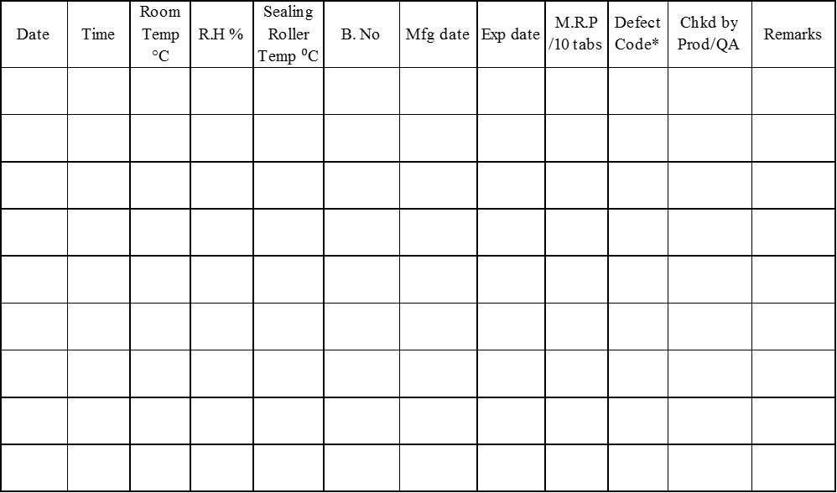

* Defects: 1. Misprint. 2. Cut on the foil. 3. Empty Pockets. 4. Improper Seal 5. Any Other-Specify.

**N.B. Enclose additional sheets if required, to be endorsed by QA.**

**P A C K A G I N G R E C O R D S**

**In-Process Check by QA**

**Primary Packing- Sales Pack** Machine I.D: CP-MC-BP-



Checked By & Date:

**Primary Packing- P.S. Pack** Machine I.D: CP-MC-BP-



Checked By & Date:

**Secondary Packing-Sales Pack**



Checked By & Date:

**Secondary Packing-P.S. Pack**



Checked By & Date:

**P A C K A G I N G R E C O R D S**

SECONDARY PACKING

**STAGE – 3 (OVER PRINTING OF PACKING MATERIALS)**

**Line Clearance / Check Lists for Change Over**

|  |  |  |  |  |  |
| --- | --- | --- | --- | --- | --- |
| Sl.No | Activity | Done By | Date | Checked By | |
| Prod | QA |
| 1 | Remove unused Labels / Cartons, of previous product / previous batch and destroyed unused over-printed & rejected packing materials. |  |  |  |  |
| 2 | Remove Waste from the waste bin. |
| 3 | Remove Stereos and stamps of previous product / B.No |
| 4 | Floor Cleaning as per SOP. |
| 5 | Clear Status Board mentioning Previous product / B.No and put on details of current product / B. No. put on the board. |
| Sl No | Activity | Done By | Date | Checked By | |
| Prod | QA |
| 1 | Remove unused Labels / Catch-covers of previous product / previous batch and destroyed unused over-printed & rejected packing materials. |  |  |  |  |
| 2 | Remove Waste from the waste bin |
| 3 | Remove Stereos and stamps of previous product / B.No |
| 4 | Floor Cleaning as per SOP. |
| 5 | Clear Status Board mentioning Previous product / B.No and put on details of current product / B. No. |

**Rubber Stereo Printing Details:**

|  |  |  |  |  |  |  |
| --- | --- | --- | --- | --- | --- | --- |
| **Printing Matter** | **Reference** | **Foil-Sales** | **Foil-P.S.** | **Carton** | **Shipper Box Label-Sales** | **Shipper Box Label-P.S** |
| Batch No. |  |  |  |  |  |  |
| Mfg. Date |  |  |  |  |  |  |
| Exp. Date |  |  |  |  |  |  |
| MRP incl all taxes |  |  |  |  |  |  |
| Other Details |  |  |  |  |  |  |
| Checked By-Prod |  |  |  |  |  |  |
| Checked by -QA |  |  |  |  |  |  |

**P A C K A G I N G R E C O R D S**

**STAGE-4** **(RECONCILATION OF ALUMINIUM & PVC FOILS)**

|  |  |  |  |  |  |  |
| --- | --- | --- | --- | --- | --- | --- |
| Sl. Nos. | 1 | 2 | 3 | 4 | (2 + 3 +4)/1 x 100 |  |
| Items | Quantity Received (Kg ) | Quantity Used  (Kg) | Quantity Rejected (Kg) | Quantity Returned (Kg) | Quantity Accounted For (%) | Chkd by |
| Printed Alu. Foil  (210 mm x 0.03 mm) |  |  |  |  |  |  |
| Printed Alu. Foil  (210 mm x 0.03 mm) |  |  |  |  |  |  |

Destruction of Unused Over-printed Primary Packing Materials supervised by

____________________________

Signature of QA Personnel & Date

**STAGE- 5 (SECONDARY PAKAGING**)



**In-process check during Secondary Packing:**

|  |  |  |  |  |  |  |  |  |
| --- | --- | --- | --- | --- | --- | --- | --- | --- |
| **Date** | **Time** | **B.no** | **Mfg dt.** | **Exp dt.** | **M.R.P. incl. all taxes (Rs)** | **Strip quality/ nos.** | **Fill Qty. of Carton** | **Chkd. By Prod/QA** |
|  |  |  |  |  |  |  |  |  |
|  |  |  |  |  |  |  |  |  |
|  |  |  |  |  |  |  |  |  |
|  |  |  |  |  |  |  |  |  |
|  |  |  |  |  |  |  |  |  |
|  |  |  |  |  |  |  |  |  |
|  |  |  |  |  |  |  |  |  |
|  |  |  |  |  |  |  |  |  |
|  |  |  |  |  |  |  |  |  |
|  |  |  |  |  |  |  |  |  |

**P A C K A G I N G R E C O R D S**

**Shipper Box Checking Record:**

|  |  |  |  |  |
| --- | --- | --- | --- | --- |
| Date | Time | Shipper Box No. | Fill Qty. of Shipper Box | Checked by (Prod / QA) |
|  |  |  |  |  |
|  |  |  |  |  |
|  |  |  |  |  |
|  |  |  |  |  |
|  |  |  |  |  |
|  |  |  |  |  |
|  |  |  |  |  |
|  |  |  |  |  |
|  |  |  |  |  |
|  |  |  |  |  |

**Daily Production Record**

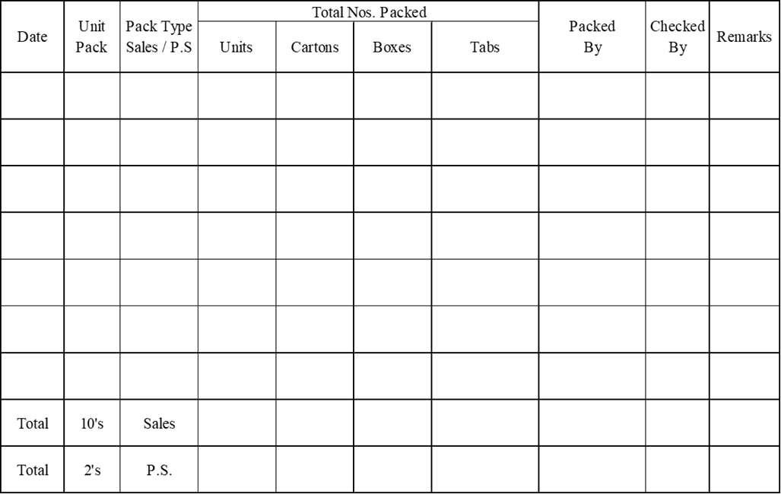

**P A C K A G I N G R E C O R D S**

**STAGE- 6 (RECONCILATION OF SECONDARY PAKAGING MATERIALS**)



Reconciled By: Date: Checked by: Date:

Destruction of Unused Over-printed Secondary Packing Materials supervised by

____________________________

Signature of QA Personnel & Date

**P A C K A G I N G R E C O R D S**

**STAGE – 7 (ACCOUNTABILITY OF Q.C SAMPLE)**

|  |  |
| --- | --- |
| Pre- Packing sample for Testing | Tabs |
| Finished sample for Testing | Tabs |
| Control Sample | Tabs |
| Stability Sample (if applicable) | Tabs |
| Total Samples | Tabs |

**STAGE – 7 (YIELD ANALYSIS)**

Qty. Packed:

Theoretical Yield = Batch size = Nos.

Actual Yield (Testing sample + Control Sample + Stability Sample + Qty. Packed):

% Yield = (Actual Yield / Batch Size) x 100 =

% Loss = (Batch size – Batch yield) / Batch size x 100 =

**STAGE – 8 (DELIVERY TO FINISHED STORE)**

|  |  |  |  |  |  |
| --- | --- | --- | --- | --- | --- |
| DATE | SHIPPER BOX NO | SIZE OF PACKING | QTY DELEVERED | DELEVERY NOTE NO | CHKD BY |
|  |  |  |  |  |  |
|  |  |  |  |  |  |
|  |  |  |  |  |  |
|  |  |  |  |  |  |
|  |  |  |  |  |  |
|  |  |  |  |  |  |
|  |  |  |  |  |  |

BPR Reviewed By (Production) BPR Reviewed By (QA)

**P A C K A G I N G R E C O R D S**

**Attach the following:**

**Specimen Aluminum Foil(s)**

**Specimen shipper box label(s)**

**Specimen Carton**

**Specimen Catch-cover**